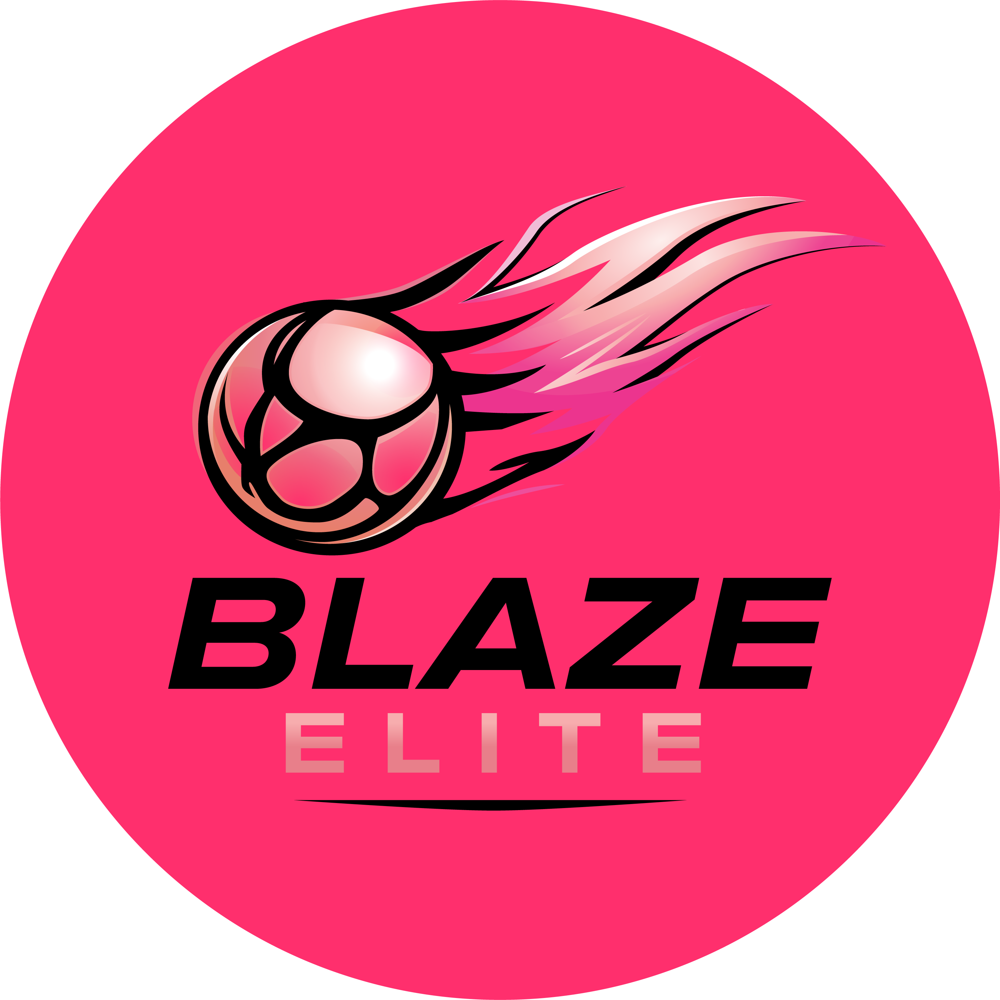

Adoption of England Netball Policies
Blaze Elite Netball Club
Blaze Elite is affiliated to England Netball, and formally adopts England Netball's national policies in full, rather than issuing our own versions of these documents. Where England Netball updates a policy, the current version at the link below always applies to Blaze Elite.

Policies Adopted in Full
- Safeguarding Children and Young People in Netball Policy
- Recognising, Responding to and Preventing Poor Practice
- England Netball Codes of Conduct & Disciplinary Regulations
- Safeguarding Disciplinary Regulations
- Whistleblowing Policy
- Complaints Policy (for matters not resolved at club level — see our own Complaints & Grievance Procedure for the first step)
- Equality, Diversity & Inclusion (Diversity & Belonging) Policy
- Safeguarding Adults at Risk Policy
- Sport-Related Concussion Guidelines (approved by World Netball)

Where to Find Them
Current versions of all England Netball policies are published at englandnetball.co.uk, and questions on any of them can be directed to England Netball's safeguarding team at besafe@englandnetball.co.uk or 01509 277850.

Blaze Elite's Own Policies
Alongside these, Blaze Elite maintains its own club-specific policies and Codes of Conduct, reflecting how we operate day to day: our Constitution, Terms & Conditions, Codes of Conduct, Safeguarding & Child Protection Policy, Data Protection & Privacy Policy, Health & Safety Policy, and Social Media and Photography & Video Policies. These sit alongside, and do not replace, England Netball's national policies above.

